

SAVEETHA INSTITUTE OF MEDICAL AND TECHNICAL SCIENCES SIMATS ENGINEERING
LIST OF EXPERIMENTS
SUB CODE & NAME: CSA17- ARTIFICIAL INTELLIGENCE

- Write a Python program to solve the 8-Puzzle Problem. (CO1)
from collections import deque

def solve(start, goal):
queue = deque([(start, [])])
visited = {tuple(start)}

while queue:
state, path = queue.popleft()

if state == goal:
path.append(state)
for s in path:
print(s[:3])
print(s[3:6])
print(s[6:])
print()
return

zero = state.index(0)
row, col = divmod(zero, 3)

for r, c in [(row-1, col), (row+1, col),
(row, col-1), (row, col+1)]:
if 0 <= r < 3 and 0 <= c < 3:
pos = r * 3 + c
new_state = state[:]
new_state[zero], new_state[pos] = new_state[pos], new_state[zero]

if tuple(new_state) not in visited:
visited.add(tuple(new_state))
queue.append((new_state, path + [state]))

print("No solution exists.")

start = []
goal = []

print("Enter the initial state (use 0 for blank):")
for i in range(3):
start.extend(map(int, input().split()))

print("Enter the goal state:")
for i in range(3):
goal.extend(map(int, input().split()))

print("\nSolution steps:")
solve(start, goal)
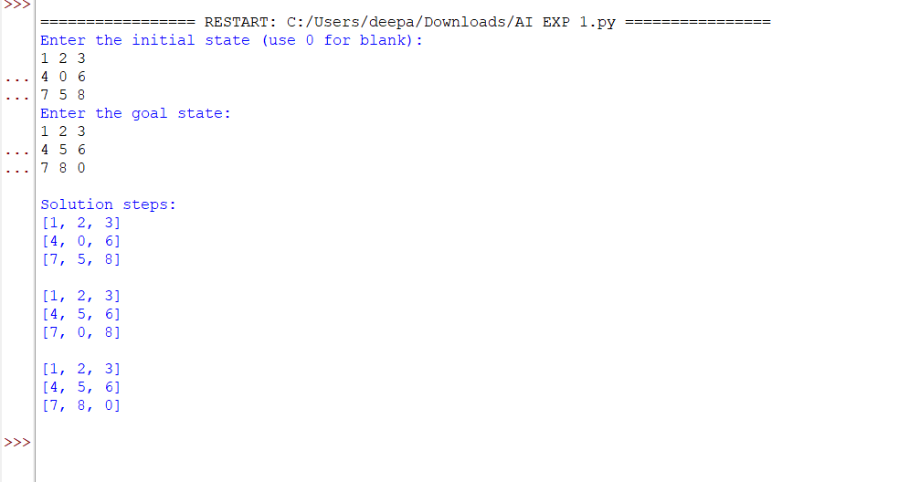
- Write a Python program to solve the 8-Queen Problem. (CO1)
def solve(board, row):
if row == 8:
for r in board:
print(" ".join("Q" if x else "." for x in r))
return True

for col in range(8):
if all(
board[i][col] == 0 and
(row - i != abs(col - j))
for i in range(row)
for j in range(8) if board[i][j] == 1
):
board[row][col] = 1

if solve(board, row + 1):
return True

board[row][col] = 0

return False

board = [[0] * 8 for _ in range(8)]

print("Solution:")
solve(board, 0)
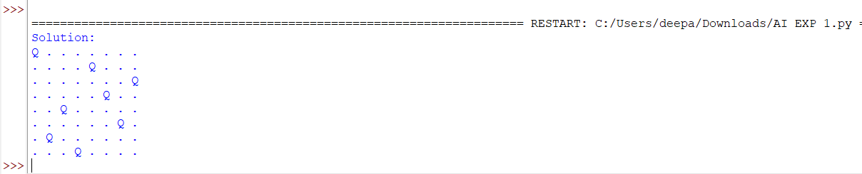
- Write a Python program to solve the Water Jug Problem. (CO2)
from collections import deque

def water_jug(capacity1, capacity2, target):
queue = deque([(0, 0)])
visited = set()

while queue:
x, y = queue.popleft()

if (x, y) in visited:
continue

visited.add((x, y))
print(x, y)

if x == target or y == target:
print("Target reached!")
return

next_states = [
(capacity1, y),
(x, capacity2),
(0, y),
(x, 0),
(x - min(x, capacity2 - y),
y + min(x, capacity2 - y)),
(x + min(y, capacity1 - x),
y - min(y, capacity1 - x))
]

for state in next_states:
if state not in visited:
queue.append(state)

print("Solution not possible.")

a = int(input("Enter capacity of Jug 1: "))
b = int(input("Enter capacity of Jug 2: "))
target = int(input("Enter target amount: "))

print("Steps (Jug 1, Jug 2):")
water_jug(a, b, target)
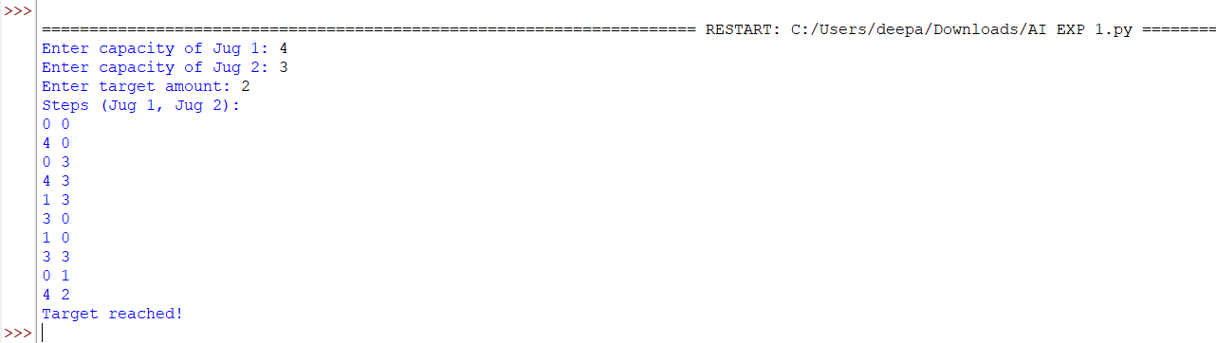
- Write a Python program to solve the Crypt-Arithmetic Problem. (CO2)
from itertools import permutations

def solve():
letters = "SENDMORY"

for p in permutations(range(10), len(letters)):
d = dict(zip(letters, p))

if d['S'] == 0 or d['M'] == 0:
continue

send = 1000*d['S'] + 100*d['E'] + 10*d['N'] + d['D']
more = 1000*d['M'] + 100*d['O'] + 10*d['R'] + d['E']
money = 10000*d['M'] + 1000*d['O'] + 100*d['N'] + 10*d['E'] + d['Y']

if send + more == money:
print("SEND =", send)
print("MORE =", more)
print("MONEY =", money)
return

solve()
- Write a Python program to solve the Missionaries and Cannibals Problem. (CO3)
from collections import deque

def solve():
start = (3, 3, 1)
goal = (0, 0, 0)

queue = deque([(start, [])])
visited = {start}

moves = [(1, 0), (2, 0), (0, 1), (0, 2), (1, 1)]

while queue:
state, path = queue.popleft()
m, c, boat = state

if state == goal:
for step in path + [state]:
print(step)
return

for dm, dc in moves:
if boat == 1:
nm, nc = m - dm, c - dc
nb = 0
else:
nm, nc = m + dm, c + dc
nb = 1

if not (0 <= nm <= 3 and 0 <= nc <= 3):
continue

rm, rc = 3 - nm, 3 - nc

if (nm > 0 and nm < nc) or (rm > 0 and rm < rc):
continue

new_state = (nm, nc, nb)

if new_state not in visited:
visited.add(new_state)
queue.append((new_state, path + [state]))

print("No solution exists.")

print("Steps (Missionaries, Cannibals, Boat):")
solve()

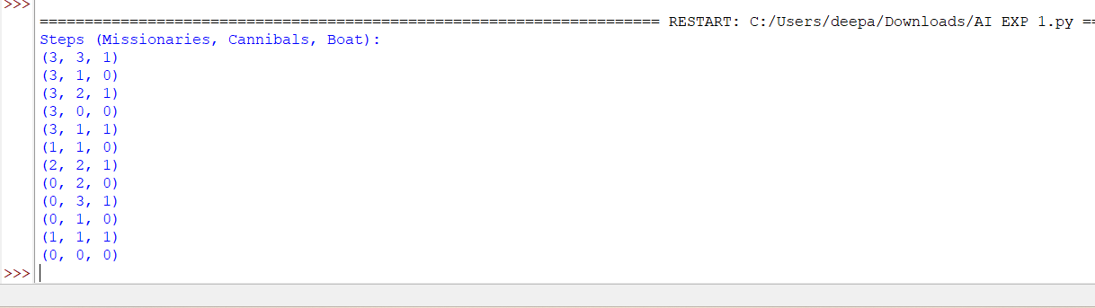

6.Write a Python program to solve the Vacuum Cleaner Problem. (CO3)
def vacuum_cleaner():
room = {
'A': input("Enter status of Room A (dirty/clean): ").lower(),
'B': input("Enter status of Room B (dirty/clean): ").lower()
}

position = input("Enter vacuum position (A/B): ").upper()

while 'dirty' in room.values():
print("Vacuum is in Room", position)

if room[position] == 'dirty':
print("Cleaning Room", position)
room[position] = 'clean'

elif position == 'A':
position = 'B'
print("Moving to Room B")

else:
position = 'A'
print("Moving to Room A")

print("All rooms are clean!")
print(room)

vacuum_cleaner()
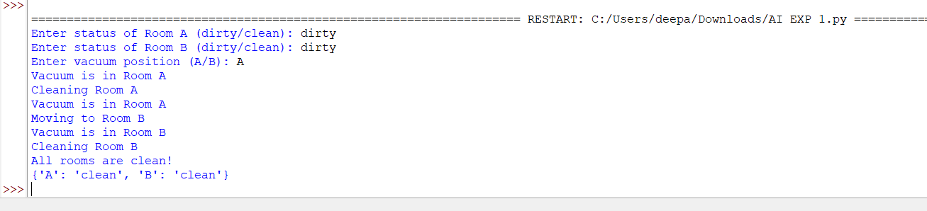

7.Write a Python program to implement Breadth-First Search (BFS). (CO3)
from collections import deque

def bfs(graph, start):
visited = set()
queue = deque([start])

while queue:
node = queue.popleft()

if node not in visited:
print(node, end=" ")
visited.add(node)

for neighbor in graph[node]:
if neighbor not in visited:
queue.append(neighbor)

graph = {
'A': ['B', 'C'],
'B': ['D', 'E'],
'C': ['F'],
'D': [],
'E': [],
'F': []
}

start = input("Enter starting node: ").upper()

print("BFS Traversal:")
bfs(graph, start)
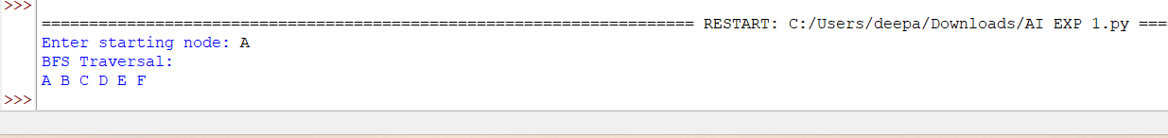
8.Write a Python program to implement Depth-First Search (DFS). (CO4)
def dfs(graph, node, visited):
if node not in visited:
print(node, end=" ")
visited.add(node)

for neighbor in graph[node]:
dfs(graph, neighbor, visited)

graph = {
'A': ['B', 'C'],
'B': ['D', 'E'],
'C': ['F'],

'D': [],
'E': [],
'F': []
}

start = input("Enter starting node: ").upper()

print("DFS Traversal:")
dfs(graph, start, set())
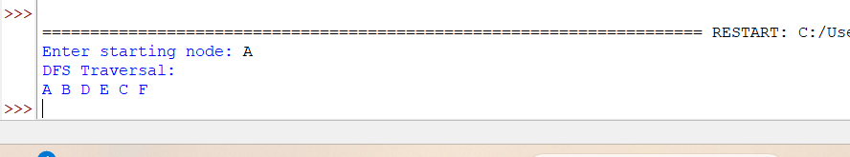

9.Write a Python program to solve the Travelling Salesman Problem (TSP). (CO4)
from itertools import permutations

def tsp(graph, start):
cities = list(graph.keys())
cities.remove(start)

min_cost = float('inf')
best_path = []

for path in permutations(cities):
route = [start] + list(path) + [start]
cost = 0

for i in range(len(route) - 1):
cost += graph[route[i]][route[i + 1]]

if cost < min_cost:
min_cost = cost
best_path = route

print("Shortest Path:", " -> ".join(best_path))
print("Minimum Cost:", min_cost)

graph = {
'A': {'A': 0, 'B': 10, 'C': 15, 'D': 20},
'B': {'A': 10, 'B': 0, 'C': 35, 'D': 25},
'C': {'A': 15, 'B': 35, 'C': 0, 'D': 30},
'D': {'A': 20, 'B': 25, 'C': 30, 'D': 0}
}

start = input("Enter starting city (A/B/C/D): ").upper()

print("Travelling Salesman Problem:")
tsp(graph, start)
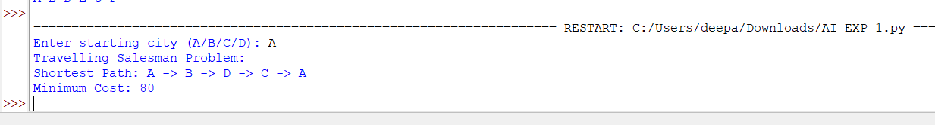
10.Write a Python program to implement the A* Search Algorithm. (CO4)
def astar(graph, heuristic, start, goal):
open_list = [(start, 0)]
cost = {start: 0}
parent = {}

while open_list:
open_list.sort(key=lambda x: x[1])
node, _ = open_list.pop(0)

if node == goal:
path = []
while node in parent:
path.append(node)
node = parent[node]
path.append(start)
path.reverse()

print("Shortest Path:", " -> ".join(path))
print("Total Cost:", cost[goal])
return

for neighbor, weight in graph[node].items():
new_cost = cost[node] + weight

if neighbor not in cost or new_cost < cost[neighbor]:
cost[neighbor] = new_cost
parent[neighbor] = node
f = new_cost + heuristic[neighbor]
open_list.append((neighbor, f))

print("No path found.")

graph = {
'A': {'B': 1, 'C': 4},
'B': {'A': 1, 'C': 2, 'D': 5},
'C': {'A': 4, 'B': 2, 'D': 1},
'D': {'B': 5, 'C': 1}
}

heuristic = {
'A': 4,
'B': 3,
'C': 1,
'D': 0
}

start = input("Enter starting node: ").upper()
goal = input("Enter goal node: ").upper()

print("A* Search Algorithm:")
astar(graph, heuristic, start, goal)
